Tensor flow and Keras

This is also used for Development, Researcher, deployment of the algorithms.

The core implementation of Tensorflow is in c/c++ and python, java and java script.
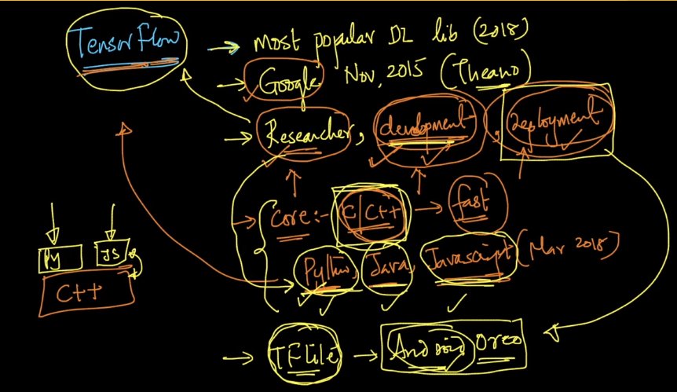

Tensor is the mathematical term for 1d tensor and 2d tensor, 3d tensors. Flow is because of back propagation.
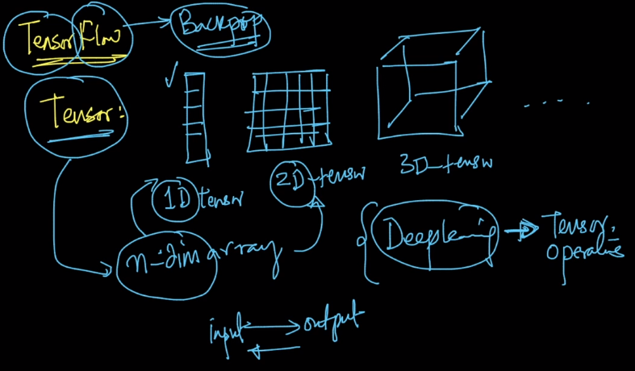

Tensorflow code is intricate and gives lots of low level control, the code is typically longer.

Keras simplifies the code. This is a wrapper around tensorflow. It is extremely easy to learn.

There are many other libraries like TF, Theano, caffe2, pytorch and MXNET.

Keras2 provides some low level control.

GPU vs. CPU:

Difference between CPU’s and GPU’s. This is random access memory.

Architecture:
CPU: Cache stores all the memory for the cores in the CPU. This is on chip memory.
We can store the B matrix on the cache to make computations in B more fast by the cores in CPU’s.
There are only few cores in CPU’s.
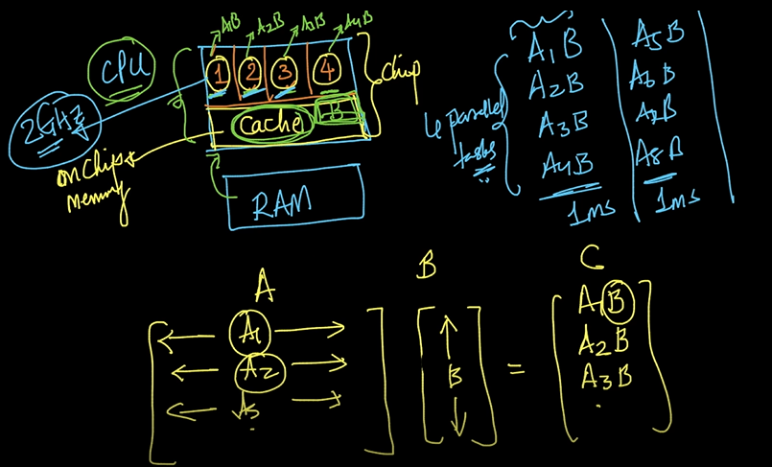

GPU: In GPU’s we have lot of cores in 100’s and 1024’s. Each GPU core is much slower than CPU, but there are many of them. The single block has the 1 core and 1 cache. This is called the distributed cache.

This sum of all the cache’s is called the distributed RAM. CUDA is the programming environment that is used to perform the parallel processing that is used to program the NVIDIA GPU’s.

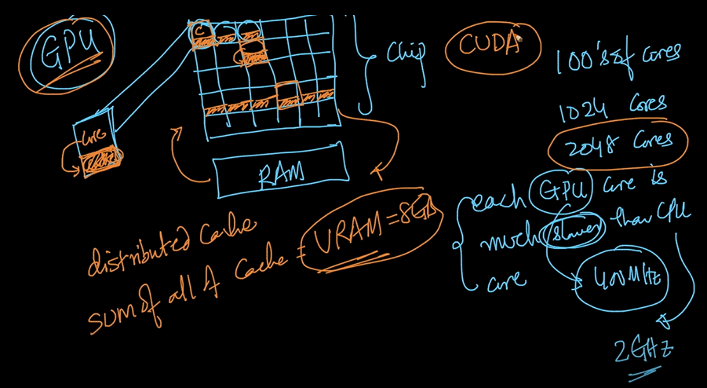

We can distribute the ram into many blocks of code, we can do lot of parallel operations. The thousands of parallel tasks run at once. We can distribute A and B multiplications parallely.
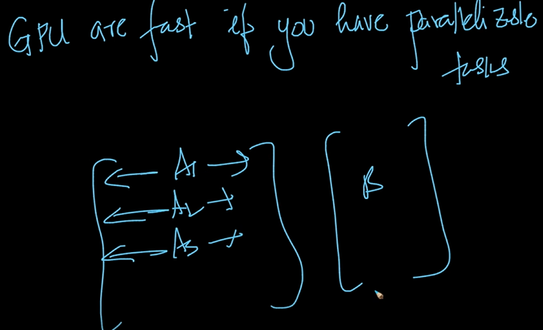

Deep learning has lot Tensor operations. We can do on whole matrix of weights.
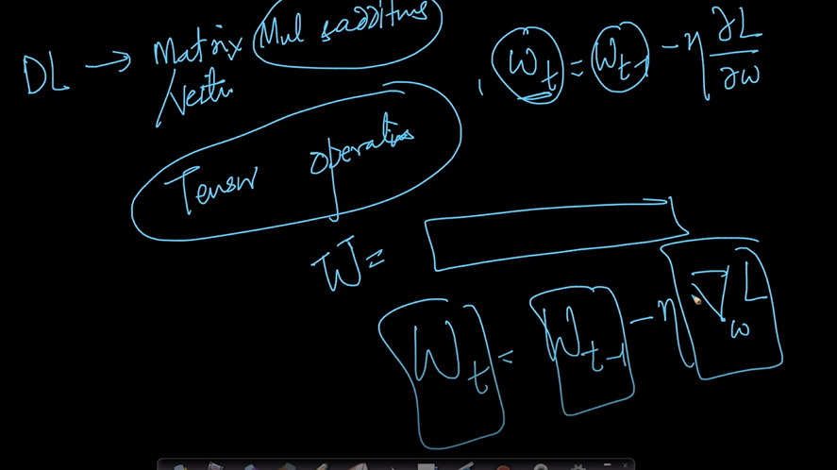
We are doing the update with matrix operations.

Google colab:
It is a tool on google servers. This is exactly like a Ipython notebook.

Installing Tensorflow:

It is very easy to use.

Learningtensorflow.com

cloud.google.com.

We have 10 classes, we convert into a vector using the each image.

